TOUBLESHOOTING PRACTICE #3 CS1310 Dr. Redfield
Cube Calculations

Name: Weiss Del Carmen

Instructions:
The output for the program (when working correctly) is shown below. A number of errors have been put into the code. Use the chart below to indicate the errors as you find them. The code (with errors) is shown after the output; however, it would be easiest for you to run the program and make use of the error messages to troubleshoot. There are between 3 and 10 errors. You should be able to reproduce the output below once all the errors have been corrected.

Program: ts3_Cube_Calculations.c

Line # Error

55 Forgot ‘:’ in ‘case ‘V’’

29 No ‘&’ in ‘length’, ‘width’, and ‘height’

39 Forgot ‘&’ in ‘choice’ for ‘scanf’

44 Forgot to add perimeter math for ‘case p:’ and ‘break;’

46 Forgot to add ‘break;’ at the end

47 Forgot to do surface area for ‘case s:’ and ‘break;’

54 Forgot to add volume math for ‘case v:’ and ‘break;’

Output:
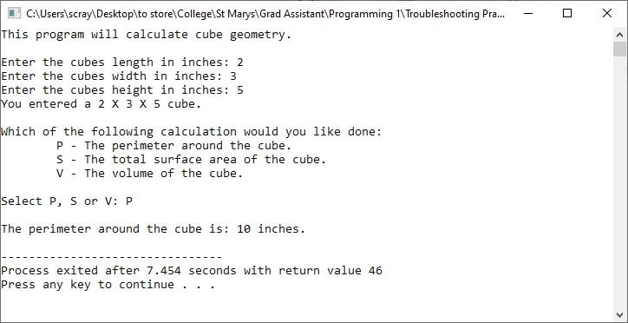

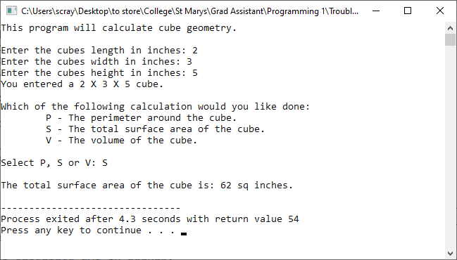

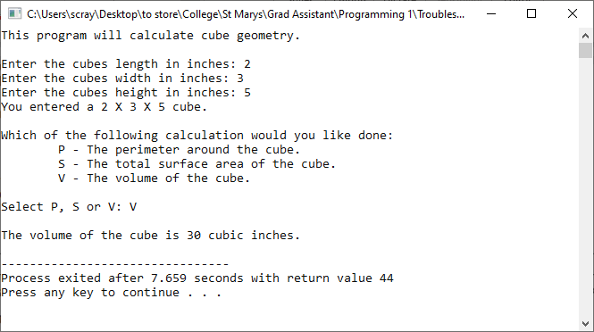

Code:
/* ==========================================================================
Troubleshooting Practice #3
Description: This program asks the user for the dimensions of a cube. It
will then calculate either the volume, total surface area, or the perimeter
around the cube based on what the user asks for.

Author: Scott Raymond
Date: 29 Aug 2020
Language: C
For Class: CS1310, Programming I
===========================================================================*/
#include <stdio.h>

void main(void)
{
int length; /* holds the cubes length in inches */
int width; /* holds the cubes width in inches */
int height; /* holds the cubes height in inches */
char choice; /* holds the users selections */

printf("This program will calculate cube geometry.\n\n");

printf("Enter the cubes length in inches: ");
scanf("%d", &length);
printf("Enter the cubes width in inches: ");
scanf("%d", &width);
printf("Enter the cubes height in inches: ");
scanf("%d", &height);
printf("You entered a %d X %d X %d cube.\n\n", &length, &width, &height);

getchar(); /* captures the newline character in the buffer */

/* display a menu for the user to select from, and get selection */
printf("Which of the following calculation would you like done:\n");
printf("\tP - The perimeter around the cube.\n");
printf("\tS - The total surface area of the cube.\n");
printf("\tV - The volume of the cube.\n");
printf("\nSelect P, S or V: ");
scanf("%c", choice);

/* switch on the choice and make the calculations */
switch (choice)
{
case 'p':
case 'P':
printf("\nThe perimeter around the cube is: %d inches.\n",
(length + width) * 2);

case 's':
case 'S':
printf("\nThe surface area of the cube is: %d sq inches.\n",
((length*width)+(length*height)+(width*height))*2);
break;
case 'v':
case 'V'
printf("\nThe volume of the cube is %d cubic inches.\n",
length * width * height);
break;
default:
printf("That was an invalid selection.\n");
}

}

